**FINAL REPORT**

**Team ID:** LTVIP2026TMIDS35961

**Title:** Plugging into the Future: An Exploration of Electricity Consumption Patterns Using Tableau

**1.INTRODUCTION:**

**1.1 Project Overview**

The Electricity Consumption Analysis project focuses on analyzing and visualizing electricity usage data across different states and regions using Tableau. The project aims to transform raw electricity consumption data into meaningful insights through interactive dashboards and visual analytics. By analyzing year-wise, month-wise, and region-wise consumption patterns, the system helps in identifying trends, high and low consumption areas, and seasonal variations. The dashboard enables users to make informed decisions through dynamic filters and comparative visualizations.

## ****1.2 Purpose****

The primary purpose of this project is to provide a structured and interactive analytical platform for understanding electricity consumption patterns. It aims to simplify complex raw data into clear visual representations that support decision-making for energy analysts, planners, and policy makers. The project enhances data-driven planning, improves resource allocation strategies, and assists in identifying consumption trends for better energy management.

**2. IDEATION PHASE**

**2.1 Problem Statement**

|  |  |  |  |  |  |
| --- | --- | --- | --- | --- | --- |
| **Problem Statement (PS)** | **I am (Customer)** | **I’m trying to** | **But** | **Because** | **Which makes me feel** |
| PS – 1 | An energy analyst | Understand electricity consumption trends across states and regions | The data is available only in raw Excel format | There are no proper visualization or dashboards to interpret patterns | Confused and unable to make quick data-driven decisions |
| PS – 2 | A government energy planner | Identify high and low electricity consuming states | I cannot easily compare year-wise and month-wise consumption | The data lacks interactive filtering and comparative tools | Uncertain about resource allocation and planning |
| PS – 3 | A regional electricity distribution manager | Monitor regional electricity usage performance | It is difficult to track trends over time | There is no centralized visual analytics system | Concerned about inefficiencies in energy distribution |
| PS - 4 | A policy maker | Analyze seasonal electricity demand variations | Monthly data is complex and hard to interpret | There is no clear trend analysis visualization | Insecure about making strategic energy policies |

**2.2 Empathy Map Canvas**

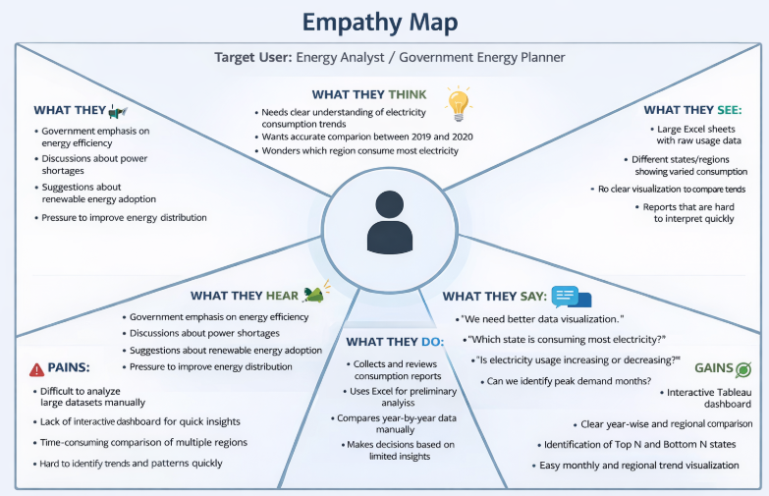

**2.3 Brainstorming**

|  |  |  |
| --- | --- | --- |
| **S. No** | **Ideas Generated** | **Category** |
| 1 | Visualize electricity consumption across different Indian states | Regional Analysis |
| 2 | Analyze consumption trends by sectors (residential, commercial, industrial) | Sectoral Insights |
| 3 | Identify peak usage hours and visualize as heatmaps | Time-based Patterns |
| 4 | Compare consumption trends across years/months (seasonal patterns) | Seasonal Variations |
| 5 | Use Tableau filters to enable dynamic interaction | Visualization Enhancements |
| 6 | Include policy implications and energy-saving tips based on findings | Impact & Recommendations |
| 7 | Forecast future consumption using historical data trends | Predictive Analysis |
| 8 | Highlight states with highest and lowest per capita electricity usage | Benchmarking |
| 9 | Show changes in urban vs rural electricity consumption | Demographic Comparison |
| 10 | Integrate external datasets like population or weather for deeper insights | Data Enrichment |

**3. REQUIREMENT ANALYSIS**

**3.1 Customer Journey map**

**Customer Journey Stages:**

**Stage 1:Problem Awareness**

User Realization:

* Electricity demand fluctuates unpredictably.
* Seasonal peaks cause overload.
* Lockdown impacted consumption patterns. Pain Points:
* Raw CSV data difficult to interpret.
* No centralized dashboard.
* Hard to compare region-wise usage.

## Stage 2: Data Exploration

User Actions:

* Access Tableau dashboard
* Select Year (2019 / 2020)
* Filter by Region
* Compare States System Response:
* Displays time-series graphs
* Shows Top N / Bottom N states
* Provides regional comparison map

## Stage 3: Insight Discovery

User Discovers:

* Southern region consumes highest power.
* 2020 lockdown reduced industrial consumption.
* Summer months show peak demand.
* Certain states show consistent growth trend.

## Stage 4: Decision Making

User Decisions:

* Allocate more supply during peak months.
* Promote off-peak usage incentives.
* Improve grid infrastructure in high-demand regions.
* Plan renewable energy investment.

**3.2 Solution Requirement**

**Functional Requirements:**

|  |  |  |
| --- | --- | --- |
| **FR No.** | **Functional Requirement (Epic)** | **Sub Requirement (Story / Sub-Task)** |
| FR-1 | Data Collection & Import | |  | | --- | | Import electricity consumption dataset into Tableau |  |  |  |  | | --- | --- | --- | |  |  | Support CSV/Excel data format |  |  |  |  | | --- | --- | --- | |  |  | Clean and prepare dataset for visualization | |
| FR-2 | Data Processing | |  | | --- | | Perform data cleaning (remove null values, formatting) |  |  |  |  | | --- | --- | --- | |  |  | Create calculated fields for year, region and monthly usage |  |  |  |  | | --- | --- | --- | |  |  | Categorize states into regions (WR, NR, SR, ER, NER) | |
| FR-3 | Visualization Creation | |  | | --- | | Create yearly electricity consumption trend chart |  |  |  |  | | --- | --- | --- | |  |  | Create region-wise consumption pie chart |  |  |  |  | | --- | --- | --- | |  |  | Create Top N and Bottom N states bar charts |  |  |  |  | | --- | --- | --- | |  |  | Create month-wise consumption charts |  |  |  |  | | --- | --- | --- | |  |  | Create India state consumption maps | |
| NFR-4 | Dashboard Development | |  | | --- | | Build interactive dashboards combining multiple visualizations |  |  |  |  | | --- | --- | --- | |  |  | Enable filtering by year and region |  |  |  |  | | --- | --- | --- | |  |  | Add titles, legends and labels for clarity |  |  |  |  | | --- | --- | --- | |  |  | Provide comparative view of 2019 vs 2020 data | |  |  |  | |  |  |  | |
| **FR No.** | **Non-Functional Requirement** | **Description** |
| NFR-1 | Usability | Dashboard should be easy to understand and interactive for non-technical users. Visualizations must be clear and self-explanatory. |
| NFR-2 | Security | Dataset used must be public/non-confidential and protected from unauthorized modification. |
| NFR-3 | Reliability | Dashboard should display accurate and consistent results based on the dataset. |
| NFR-4 | Performance | Dashboard should load and respond to filters quickly without lag. |
| NFR-5 | Availability | Dashboard should be accessible anytime through Tableau Public. |
| NFR-6 | Scalability | Solution should allow addition of future years and more states without redesigning the dashboard. |

**3.3 Data Flow Diagram**

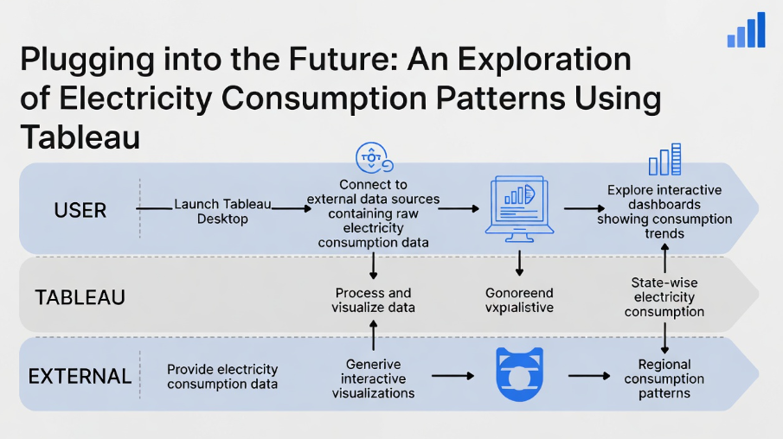**3.4 Technology Stack**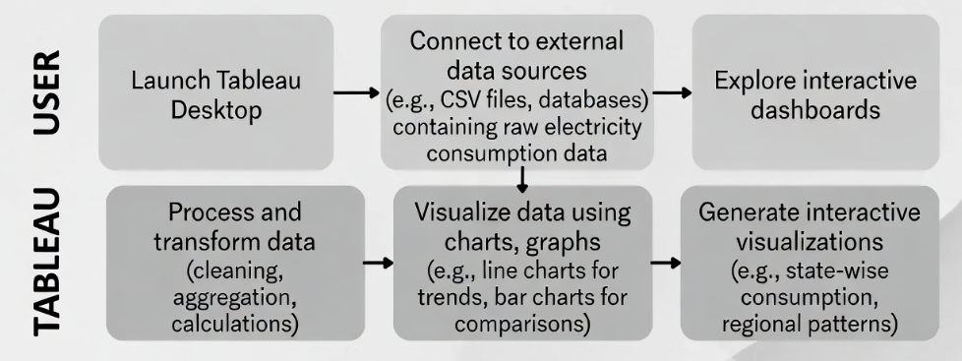

**4. PROJECT DESIGN**

**4.1 Problem Solution Fit**

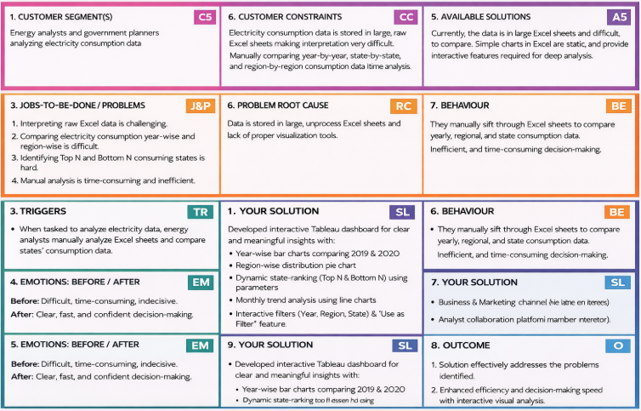

**4.2 Proposed Solution**

|  |  |  |
| --- | --- | --- |
| **S .No.** | **Parameter** | **Description** |
|  | Problem Statement (Problem to be solved) | Electricity consumption data is stored in large Excel sheets, making it difficult to interpret, compare year-wise and region-wise trends, and identify high and low consuming states. Manual analysis is time-consuming and inefficient for decision-making. |
|  | Idea / Solution description | Develop an interactive Tableau dashboard that visualizes electricity consumption data using bar charts, line charts, and pie charts. The dashboard includes year-wise comparison, region-wise distribution, Top N & Bottom N state analysis, monthly trend visualization, and interactive filters (Year, Region, State). |
|  | Novelty / Uniqueness | The solution integrates dynamic filtering, parameter-based Top N and Bottom N analysis, and cross-sheet interaction in a single dashboard. It transforms static Excel data into an interactive, user-friendly analytical system. |
|  | Social Impact / Customer Satisfaction | The dashboard helps energy planners and analysts make faster and more accurate decisions. It improves transparency in electricity consumption patterns and supports better energy planning and resource allocation. |
|  | Business Model (Revenue Model) | The solution can be adopted by government agencies, electricity boards, and energy companies. It can be implemented as a data analytics service or integrated into energy management systems for performance monitoring. |
|  | Scalability of the Solution | The dashboard can be expanded to include additional years, renewable energy data, predictive analytics, and real-time data integration. It can also be adapted for other sectors such as water consumption or fuel usage analysis. predictive analytics, and real-time data integration. It can also be adapted for other sectors such as water consumption or fuel usage analysis. |

**4.3 Solution Architecture**

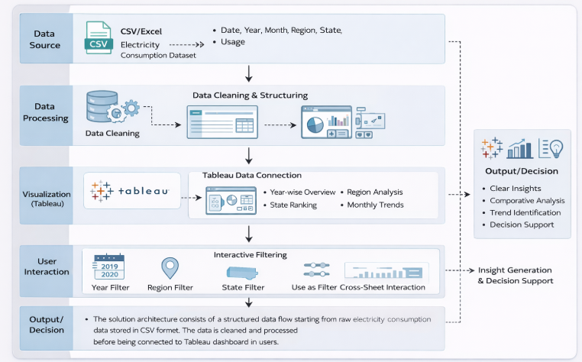

**5. PROJECT PLANNING & SCHEDULING 5.1 Project Planning**

**Product Backlog, Sprint Schedule, and Estimation**

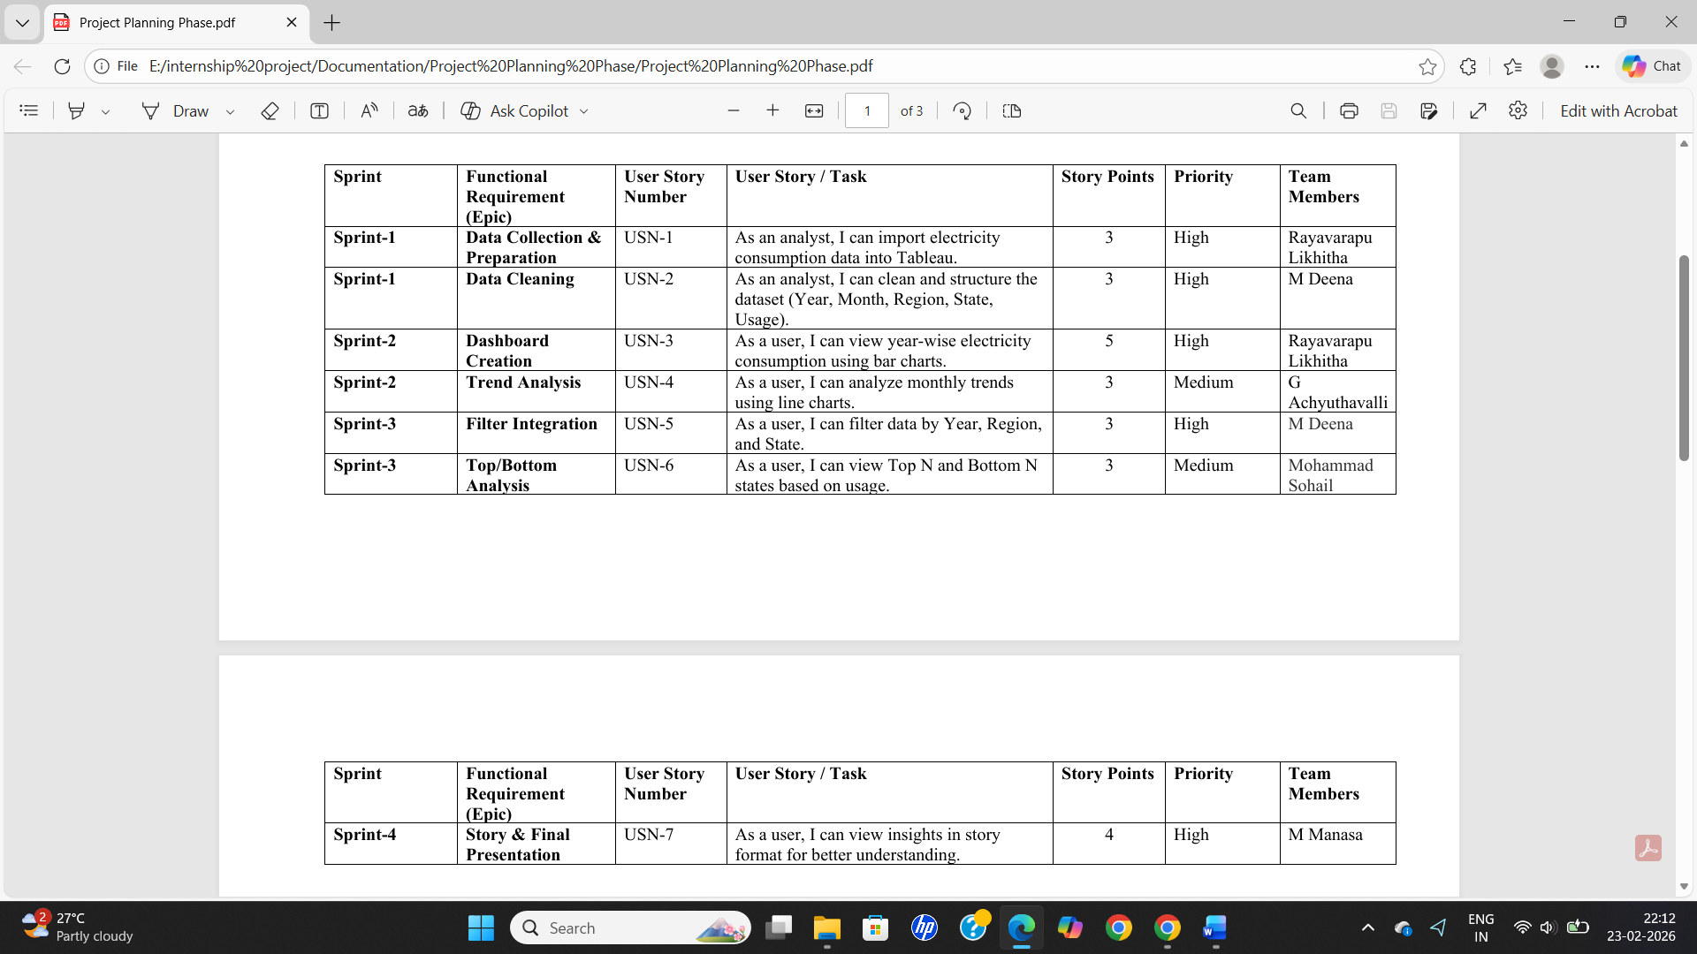

**Project Tracker, Velocity & Burndown Chart**

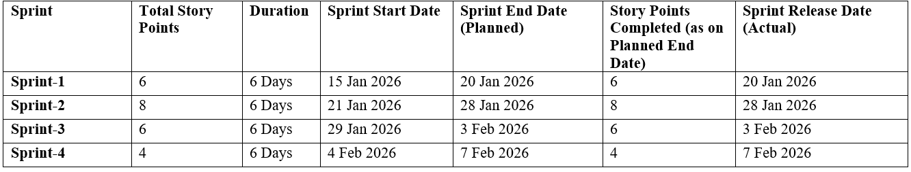

**6. FUNCTIONAL AND PERFORMANCE TESTING**

**6.1 Performance Testing**

|  |  |  |
| --- | --- | --- |
| **S.No.** | **Parameter** | **Screenshot / Values** |
|  | Data Rendered | The dashboard successfully renders electricity consumption data without delay. The dataset includes Year, Month, Region, State, and Usage fields. All visualizations load within acceptable response time. |
|  | Data Preprocessing | Data was cleaned before visualization. Date fields were structured into Year and Month hierarchy. Usage values were converted into numeric format. Null values were verified and handled appropriately. |
| 3. | Utilization of Filters | Interactive filters such as Year, Region, and State were implemented. “Use as Filter” functionality enables cross-sheet interaction. Dashboard updates dynamically when filters are applied. |
| 4. | Calculation fields Used | Calculated fields such as Total Usage (SUM), Top N / Bottom N using parameters, and Year-wise Growth were implemented to enhance analysis. |
| 5. | Dashboard design | Number of Visualizations / Graphs – 6 (Bar Chart, Pie Chart, Line Chart, Top N Analysis, Bottom N Analysis, KPI Summary). Layout is structured and responsive. |
| 6 | Story Design | Number of Visualizations / Graphs – 6. Story points are arranged logically to explain trends, comparisons, and insights step by step. |

**7. RESULTS**

**7.1 Output Screenshots**

**Dashboard Screenshots:**

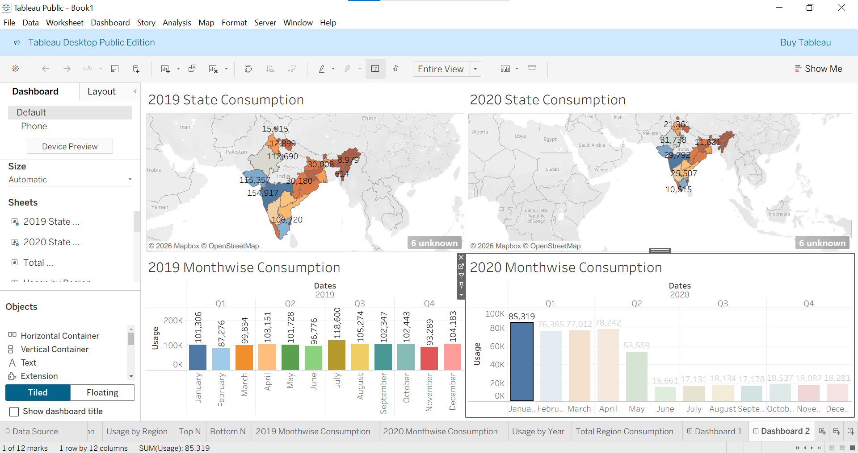

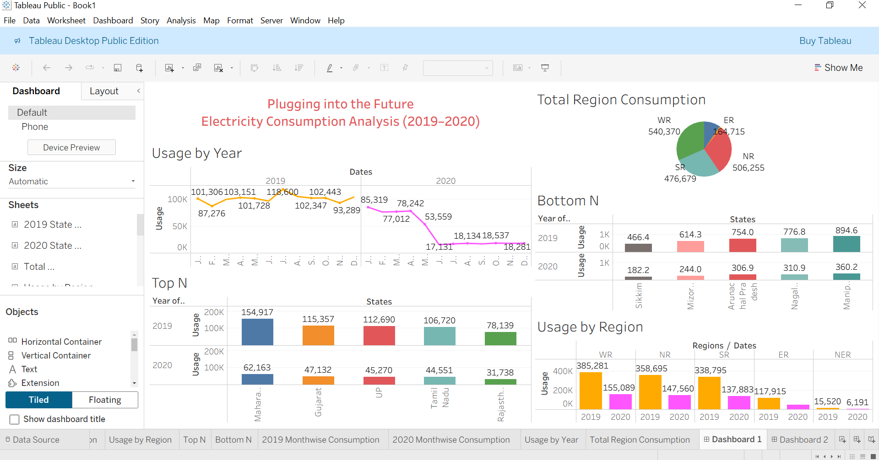

**Story**

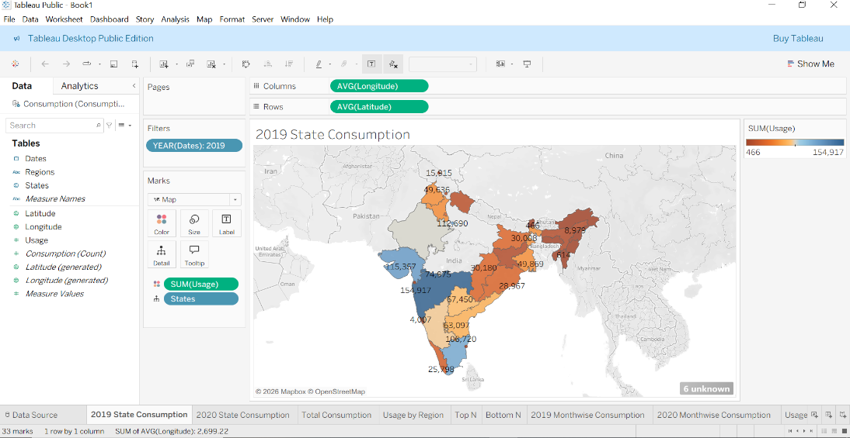

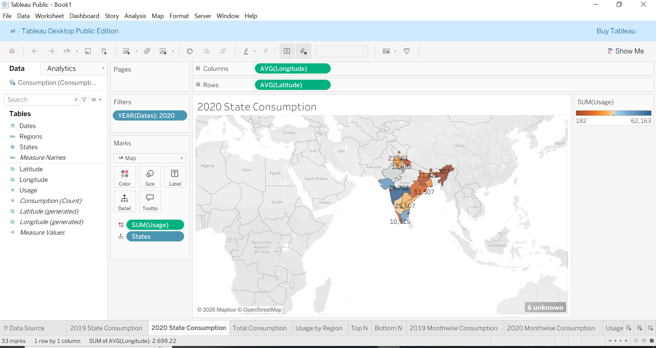

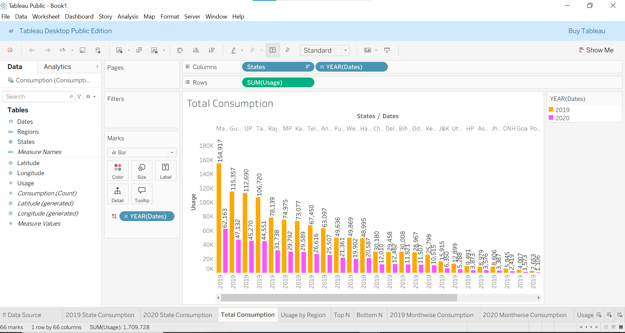

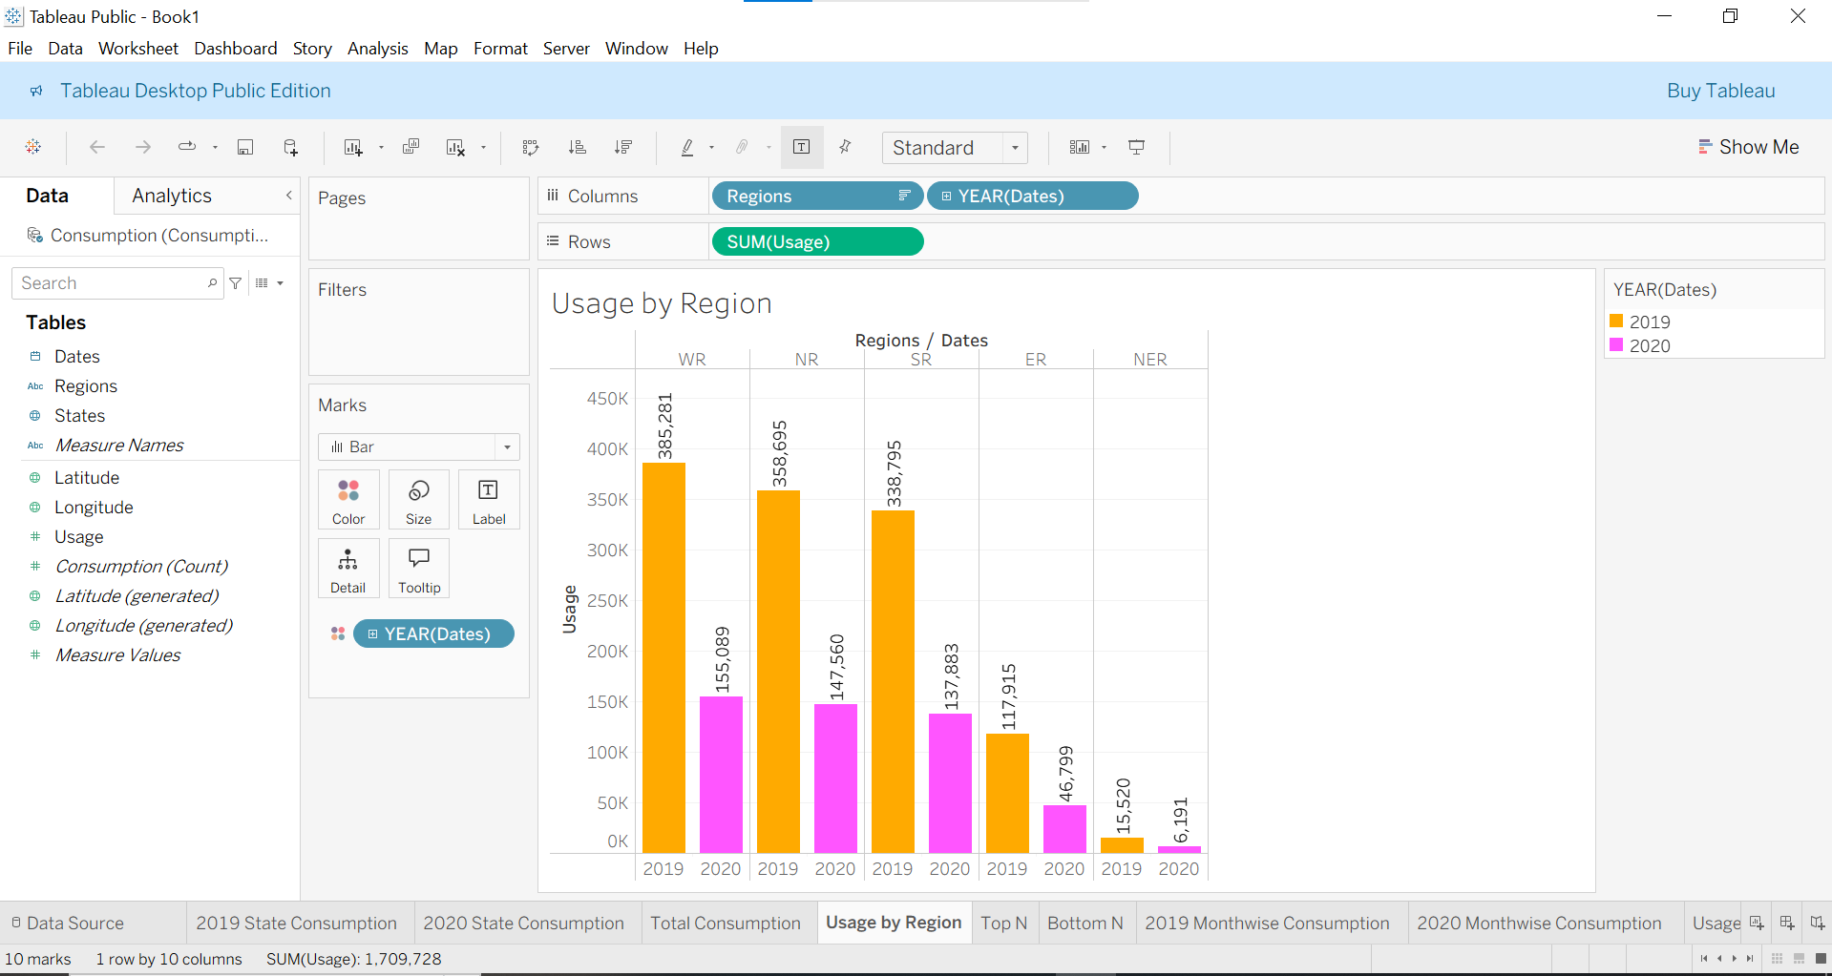

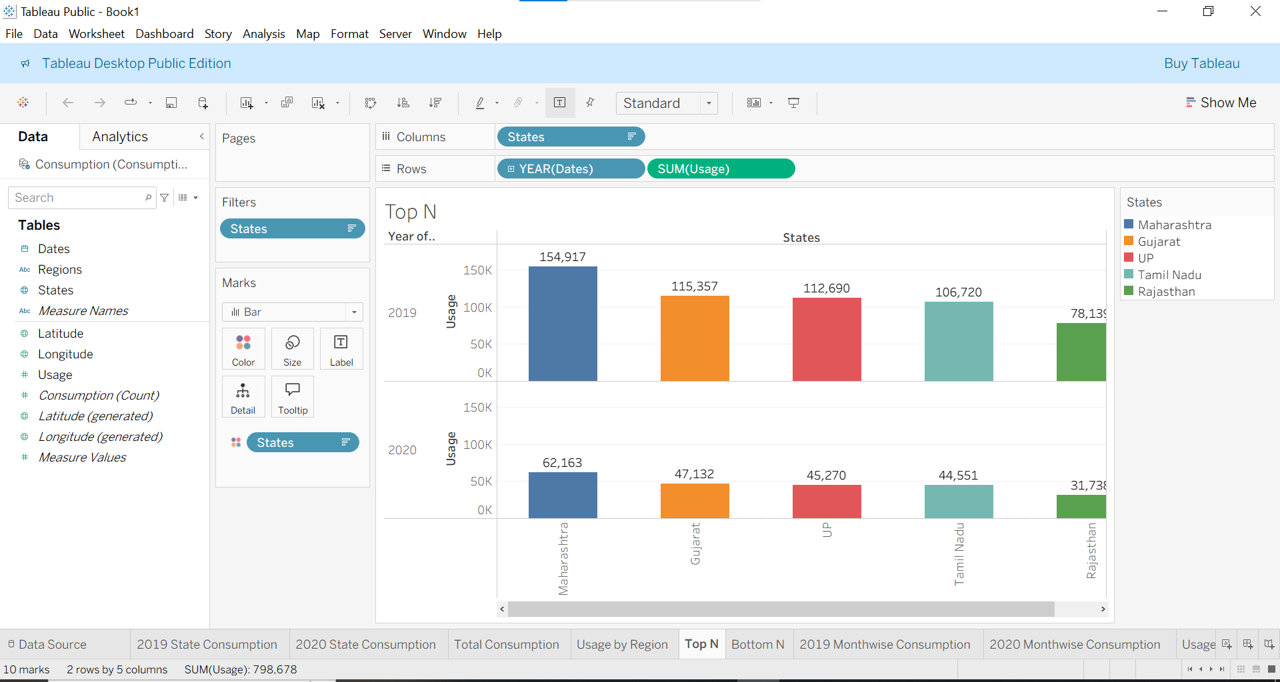

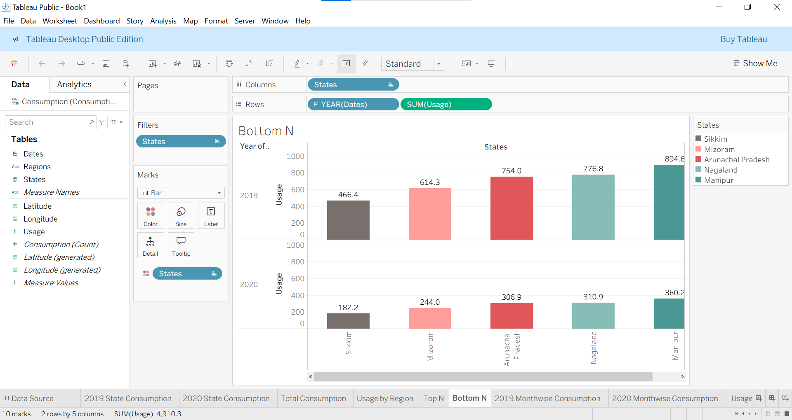

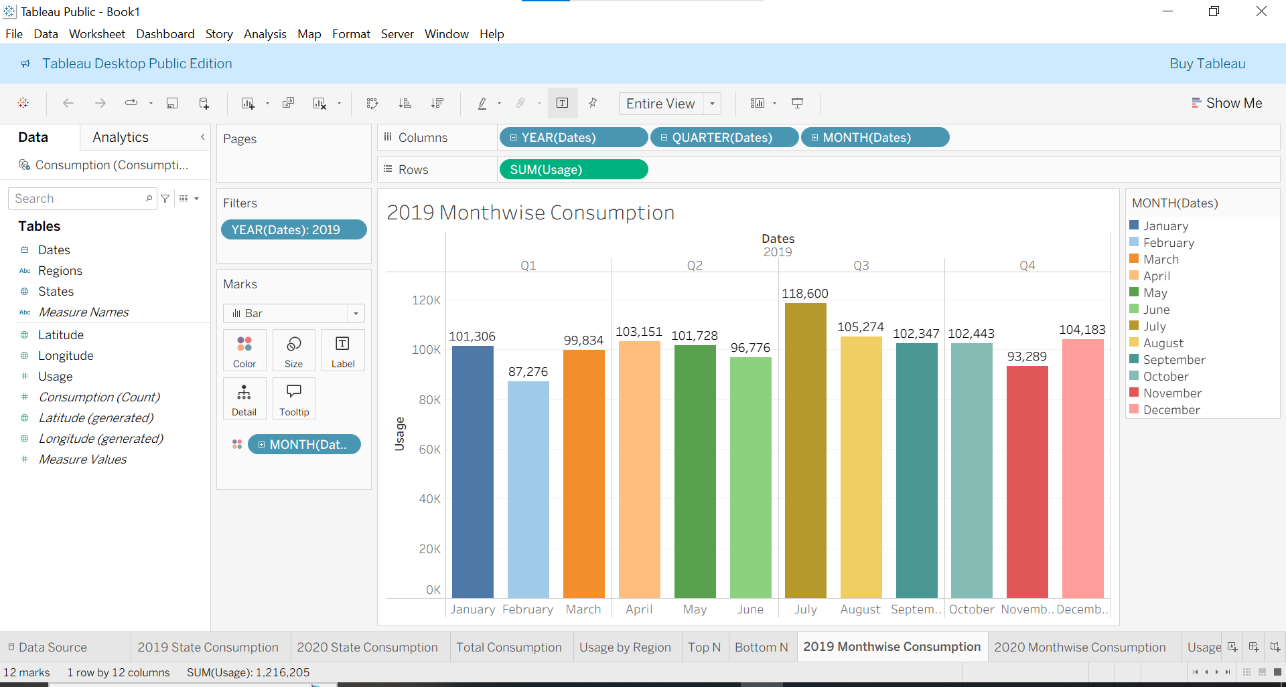

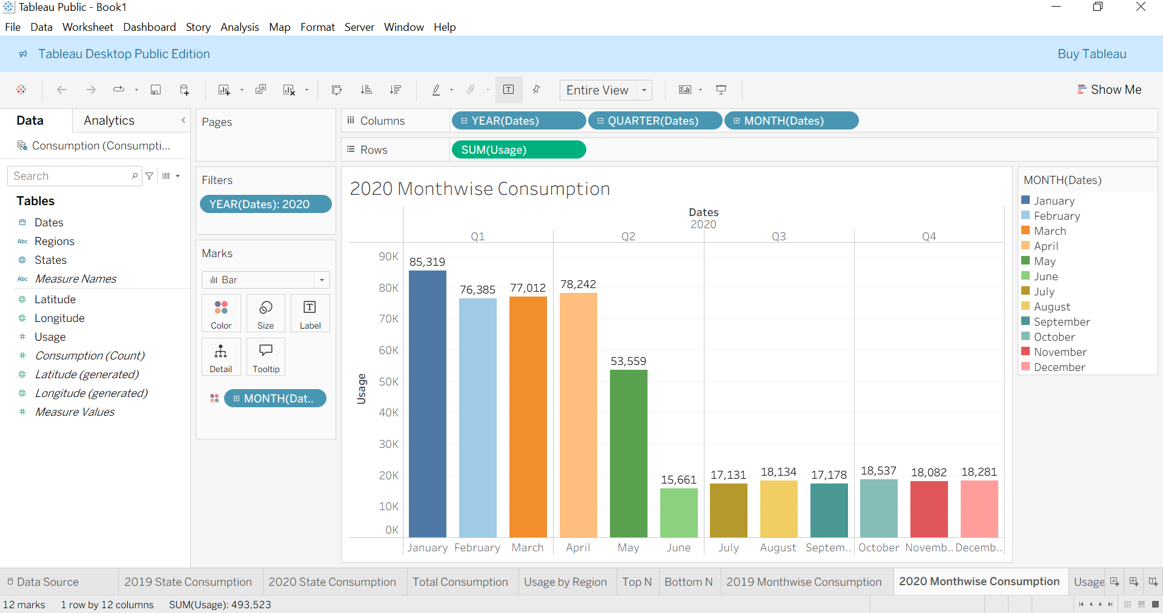

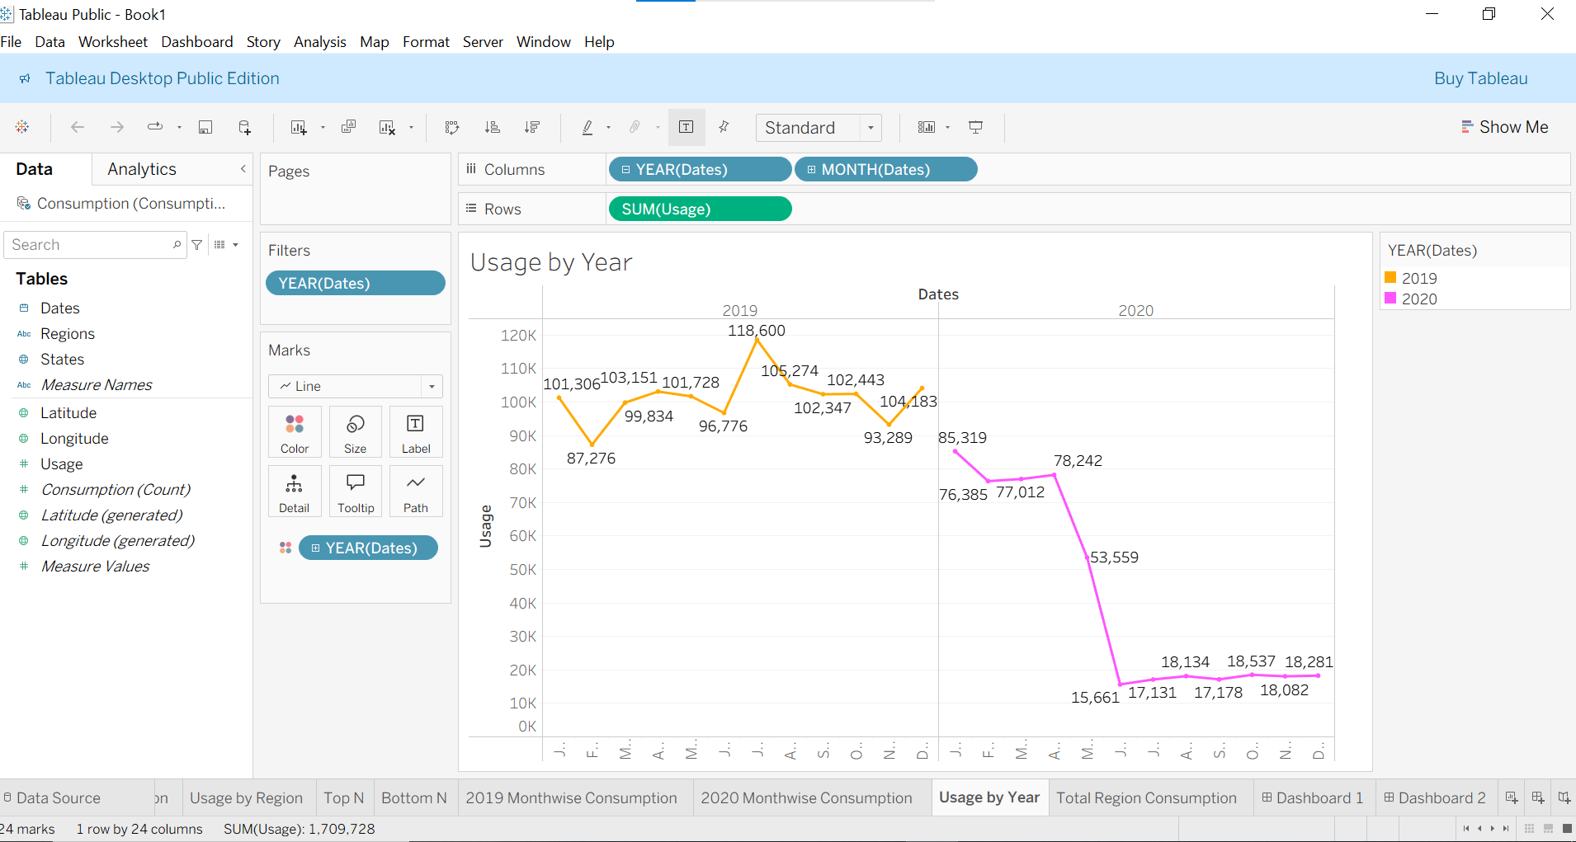

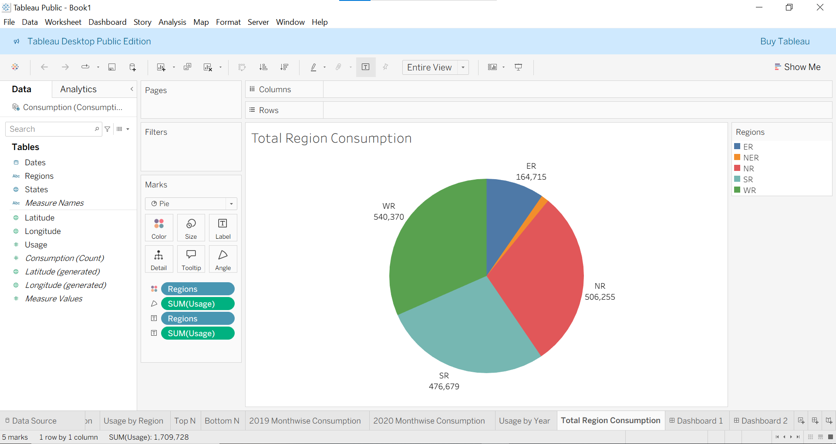

**Web Integration Screenshots:**

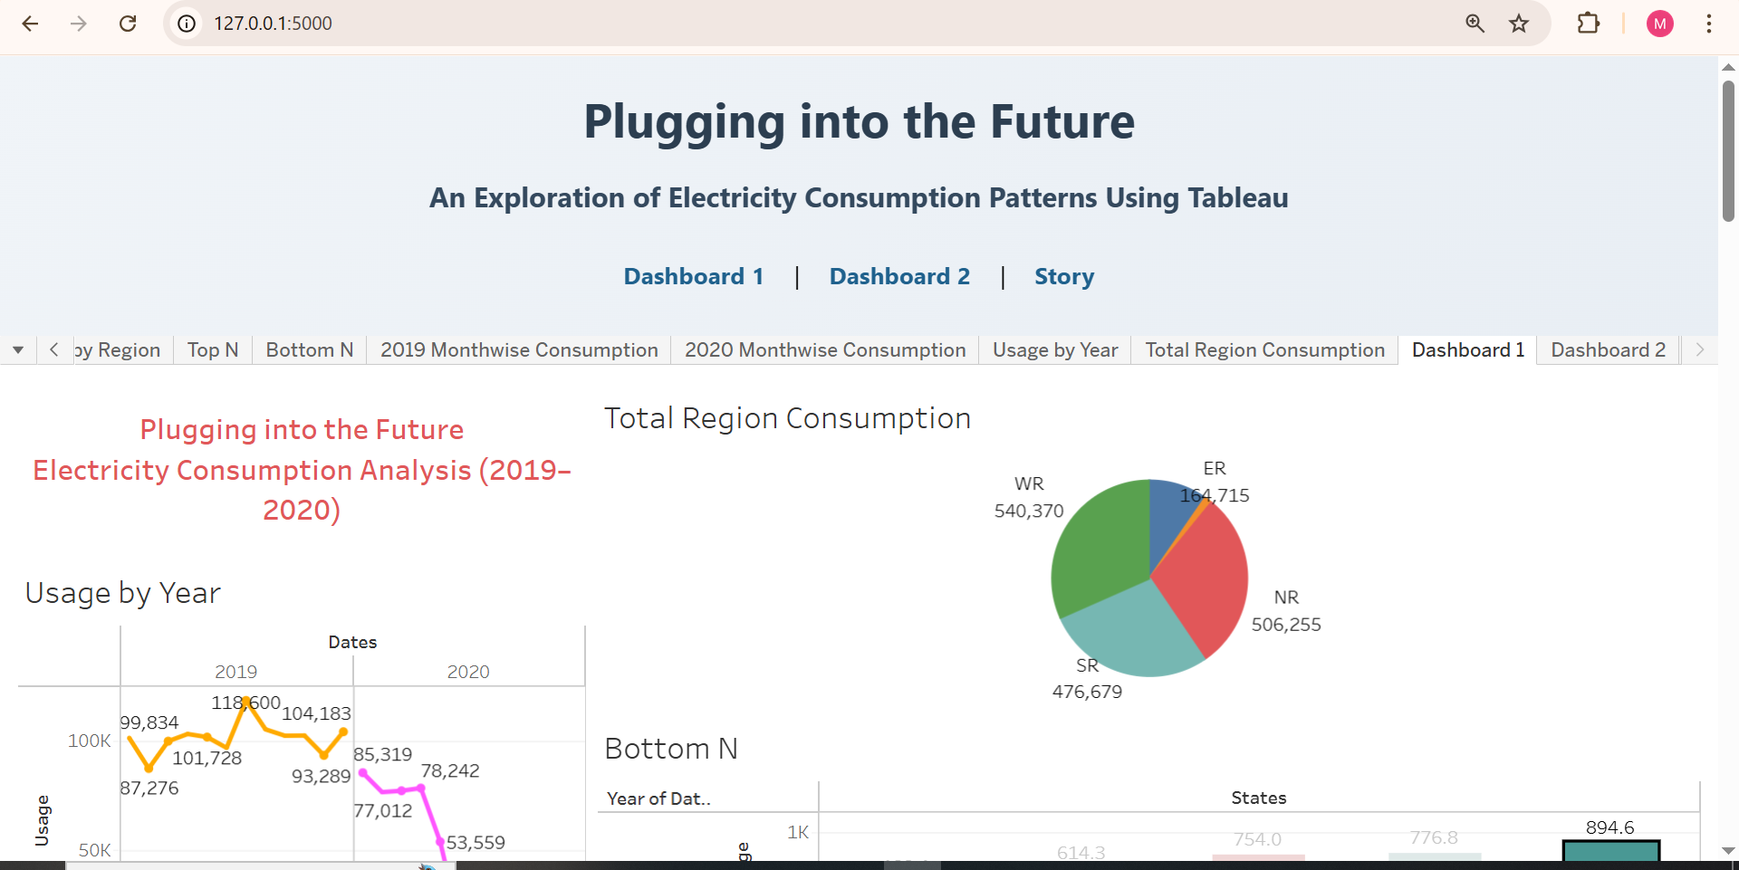

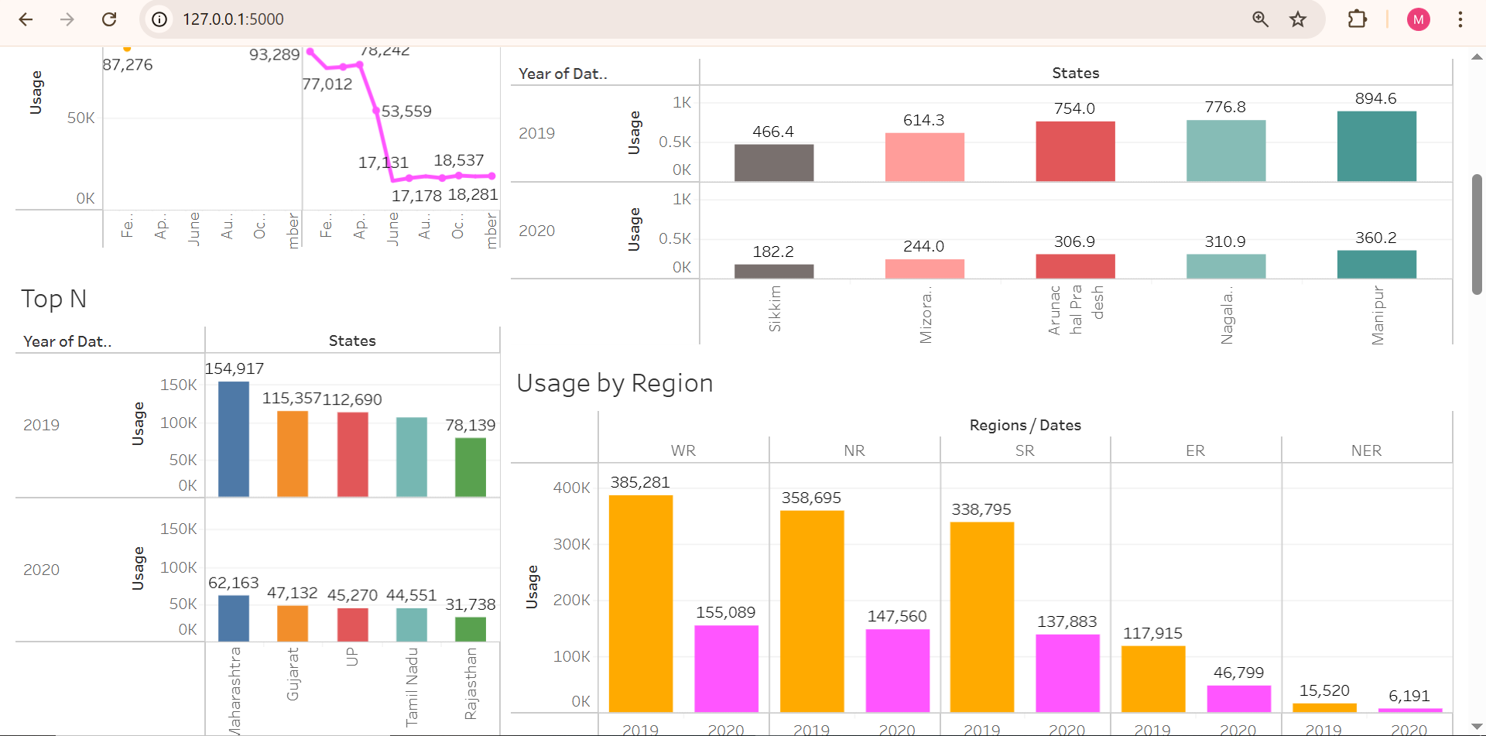

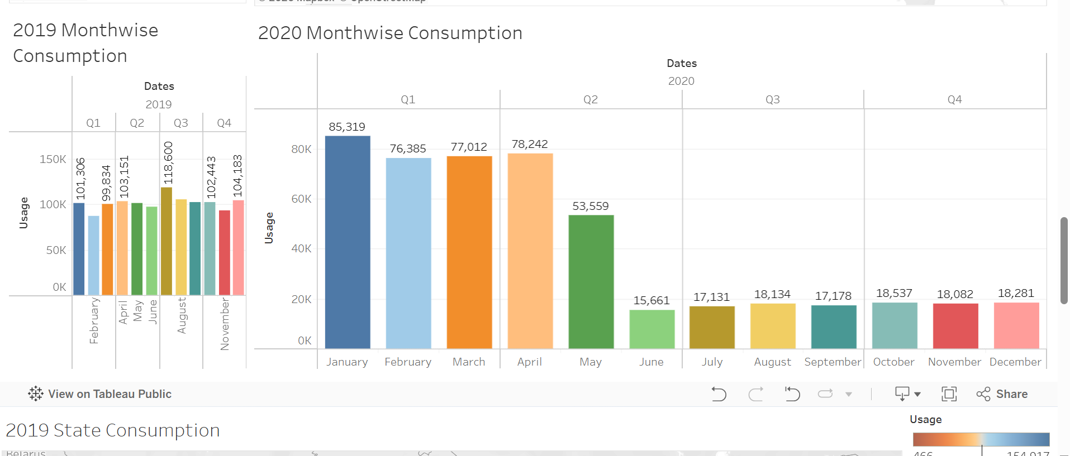

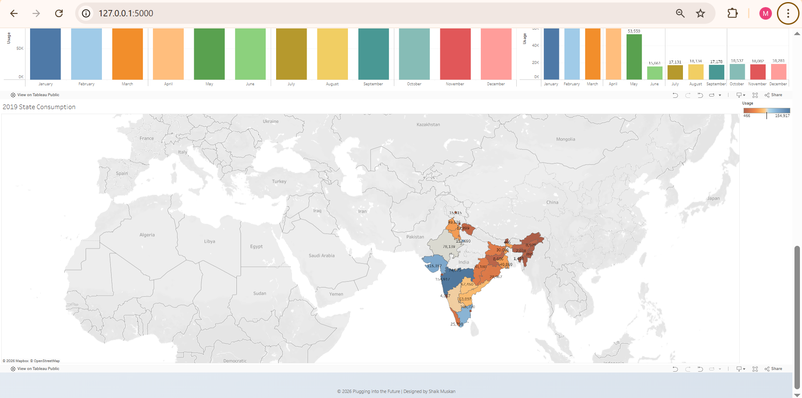

**8. ADVANTAGES & DISADVANTAGES**

## ****Advantages****

1. **Interactive Visualization**  
   The dashboard provides interactive charts and filters that allow users to explore electricity consumption data dynamically.
2. **Improved Decision Making**  
   Year-wise and region-wise analysis helps stakeholders make informed and data-driven decisions.
3. **Easy Trend Identification**  
   Monthly and seasonal trends can be easily identified through line charts and comparative analysis.
4. **Time Saving**  
   Instead of manually analyzing raw Excel data, the dashboard presents insights instantly.
5. **User-Friendly Interface**  
   The system is simple to use and does not require advanced technical knowledge.
6. **Better Resource Planning**  
   Helps energy planners identify high and low consumption regions for efficient energy distribution.

**Disadvantages**

• **Dependent on Data Quality**  
If the input data contains errors or missing values, the analysis may not be accurate.

• **Limited to Available Data**  
The dashboard can only analyze the data provided and cannot predict future consumption without advanced modeling.

• **Requires Tableau Software**  
Users need access to Tableau to interact with the dashboard.

• **Initial Setup Time**  
Data cleaning and dashboard development require initial time and effort.

**9. CONCLUSION**

The Electricity Consumption Analysis project successfully transformed raw electricity usage data into meaningful and interactive visual insights using Tableau. The developed dashboard enables year-wise, month-wise, and region-wise analysis, helping stakeholders identify consumption trends and high-demand areas. Through the use of filters, calculated fields, and comparative visualizations, the system improves decision-making and simplifies complex data interpretation. Overall, the project demonstrates how data visualization and analytics tools can enhance energy planning, resource allocation, and strategic decision-making. The solution provides a user-friendly and efficient platform for analyzing electricity consumption patterns effectively.

**10. FUTURE SCOPE**

In the future, this project can be enhanced by integrating real-time electricity data for live monitoring. Predictive analytics can be added to forecast future consumption trends. The system can also be expanded to include renewable energy analysis and deployed as a web-based platform for wider accessibility.

**11. APPENDIX**

**Source Code (if any)**

**App.py:**

from flask import Flask, render_template

app = Flask(__name__)

@app.route("/")

def home():

return render_template("index.html")

if __name__ == "__main__":

app.run(debug=True)

**Dataset Link**

<https://drive.google.com/file/d/1JxIkHNwXxjFztKq7ad0_KtkukCqTckNy/view>

**Project Demo Link**

<https://drive.google.com/file/d/11J0aqj0DB05n626_CPj1yGWWr1lQvLLg/view?usp=drive_link>

**GitHub Link**

<https://github.com/R-Likhitha/Plugging-into-the-Future-An-Exploration-of-Electricity-Consumption-Patterns-Using-Tableau>